Coach DeLiddo Classic
Toughest one day tournament in the west!!!
Double Elimination Tournament
Lemoore High School December 22, 2021

December 22,2021

WEIGH-INS: 7:00 AM All teams must be present. Weigh-ins by team. Bring Official Weigh in report!!!!!!!

Coaches meeting 8:00AM

Wrestling starts: 9:00AM ON 6 MATS

ACCOMODATIONS: Best Western 559 924 3200 (restaurant across street)
Days Inn 559 924 1261 (restaurant on location)
Sequoia Inn of Hanford 559 582 0388 (10 minutes away)
Motel 6 559 925 6100 (3 minutes away)
The Tachi Palace Hotel 1 800 615 8030 (4 minutes away)

ENTRY: $350 payable to Lemoore High School wrestling

We will accept the first 20 teams only no exception

Awards: We will have a lower and upper weight most outstanding wrestler award plus the coach Deliddo most inspirational wrestler award

Place Top 4 in each weight class

Team rosters are due the week before please send info to
dbardswrestling@gmail.com or Dbards@sbcglobal.net
Use the spread sheet below

Hope you consider our tournament. If you have any questions, call me at (559) 381-7154 Complete attached forms and return as soon as possible.

Thank you ……
Marcio Botelho
mbotelho@luhsd.K12.ca.us
botelhoclan@hotmail.com

Contract
Coach DeLiddo Classic
Entry Form
Dec 22, 2021

Please complete this entry form and return to me as soon as possible. $350 entry fee due prior to tournament.

Please (respond early as space will be reserved on first come first serve basis)

SCHOOL: _____________________________________

COACH: _____________________________________

PHONE: HOME: ________________________ WORK: _______________________

EMAIL: __________________________________________

Signature: ____________________________

Mail to:
Marcio Botelho
Lemoore High School
101 E Bush St
Lemoore, CA 93245
559 924 6600
559 381- 7154
Fax: 559 924 0429

Lemoore High School

Path of Champions Tournament
This is a One-day Wrestling tournament right before the Holidays.

Dec 22, 2022 Junior Varsity wrestling tournament
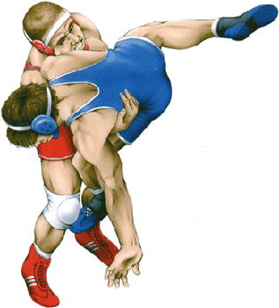
Weight-ins: 7:00am Coaches Meeting: 8:00am Wrestling Start Time 9:00am
Entry Fee: $300 per team, payable to Lemoore Wrestling
Format: We will use 8-man brackets.
Rosters: Email or fax the week before to:
dbardswrestling@gmail.com or Dbards@sbcglobal.net
Awards: Will be given to the top three place winners in each bracket. Top two team plaques
Coach’s meal will be provided. Great meal!!!!!!!!!!!!!!!
Concessions: All day
Thank you
Marcio Botelho, Lemoore High School Wrestling Coach Email -botelhoclan@hotmail.com
Please reserve your spot in the Lemoore Path of Champions Tournament. ASAP This is going to be a great wrestling tournament for all of your non-varsity wrestlers.
Contract POC
This is your entry form. Please complete and return to LHS as soon as possible. Thank you: School _____________________________________ Signature______________________________________
Fax to 559-924-6634 OR email to mbotelho@luhsd.k12.ca.us

