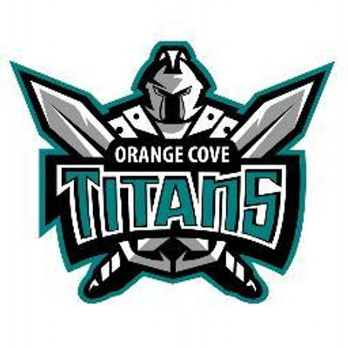
Third Annual “Lady Titan Clash”
at Orange Cove High School- No Boys Allowed
2021
When: Varsity - Saturday, December 11, 2021
Time: Weigh-ins at 8:00am, Wrestling starts at 10:00am
Where: Orange Cove High School
1700 Anchor Ave., Orange Cove, CA. 93646
Cost: $200 (14 wrestlers) due by day of tournament
$35 per wrestler for teams of 6 wrestlers or less.
Teams: Limited to the First 24 teams to turn in their contract. You can weigh-in more than 1 wrestler per weight. Only one wrestler will count towards team score.
Weights: 101, 106, 111, 116, 121, 126, 131, 137, 143, 150, 160, 170, 189, 235
plus 2 pound allowance
Format: 16-Wrestler Bracket – To avoid 5 match rule if necessary.
    - Each bracket will wrestle to 5th place
    - Consolation can only wrestle to 5th place.
    - Semi-Final loss will wrestle for 3rd and 4th.
Awards: Top 5 Medal and Top Five Teams
Coaches: 2 Coaches bands hospitality lunch
Seeding: Seeding will be done online with more information to follow.
Out of Town Teams: Spend the night in the gym option.

Tournament Director: Pablo Saenz 559-356-9814 saenz-p@kcusd.com

“Lady Titan Clash”

Saturday, December 11, 2021

School: _____________________________________________________________________________

School Phone Number: _____________________ Coach’s Cell: _____________________________

School Address: ______________________________________________________________________

School Fax:

AD’s Name: AD’s Email:

Coach’s Name: Coach’s Email:

The above-signed High School agrees to compete in the Lady Titan Clash Invitational on December 11, 2021. The tournament entry fee will be $200.00 per team or $35 per individual wrestler and must be paid by day of tournament, after which will be a $50 late fee. The tournament will be a 16-wrestler bracket. Your tournament conformation letter will be emailed to the Head Coach upon acceptance of this Contract.

Yours in Wrestling,

Pablo Saenz
Tournament Director

*Signing this contract means the participating school will be responsible for paying the entry fee to attend the tournament even if the school is unable to attend. No refunds will be given. Please sign the approval of this agreement on the appropriate line below.

Athletic Director Signature: _____________________________________ Date: _______________

Coach Signature: _____________________________________________ Date: _______________

Please make checks payable to “Orange Cove High School” and mail contract(s) to:
Orange Cove High School
Attn: Pablo Saenz Fax/Scan Contract to: 559-626-7217
1700 Anchor Ave. Email Contract to: saenz-p@kcusd.com
Orange Cove, CA 93646

